StrategicThinking

CA 3

Pizza Sales Analysis Report

Daniela Maftei

**Report on Pizza Sales Analysis 3**

1. Strategic Overview of the Business Problem 3

1.2 Background 3

1.2 Business Problem 3

1.3 Strategic Importance 4

1.4 Project Objectives 5

2. Project Plan 7

2.1 Project Management Methodology 7

2.2 Project Timeline 7

2.3 Milestones Planned 8

2.4 Anticipated Challenges 9

2.5 Roles and Responsibilities 9

3. Business Understanding 10

3.1 Domain Knowledge 10

3.2 Stakeholder Identification 11

3.3 Initial Questions 11

4. Data Understanding 12

4.1 Data Source and Description 12

4.2 Data Exploration 13

4.3 Initial Data Visualisations 14

**References 18**

# **Report on Pizza Sales Analysis**

## **1. Strategic Overview of the Business Problem**

## **1.2 Background**

The pizza industry is a significant part of the food service sector, characterized by diverse business models, ranging from small local pizzerias to large multinational chains. In this dynamic and competitive landscape, businesses are constantly seeking ways to optimize their operations, enhance customer satisfaction, and drive revenue growth. Traditionally, pizza businesses have relied on experience and intuition to make decisions regarding inventory management, marketing campaigns, and staffing. However, the increasing availability of data and advancements in data science offer unprecedented opportunities for these businesses to adopt a more data-driven approach.

Data-driven decision-making empowers pizza businesses to move beyond reactive strategies and embrace proactive approaches. By leveraging data, businesses can gain a deeper understanding of customer behavior, identify trends, and predict future outcomes. This shift enables them to make informed choices, optimize resource allocation, and personalize customer experiences, ultimately leading to improved efficiency and profitability.

### **1.2 Business Problem**

This capstone project aims to address the challenge of optimizing business operations and sales strategies for a pizza company by leveraging data analysis and machine learning. Specifically, the project focuses on the following key areas:

**Understanding Sales Patterns** by identifying trends in pizza sales, including daily, weekly, and hourly patterns, to optimize staffing and inventory.

**Analyzing Product Performance** by determining the most popular pizza categories and sizes to inform menu planning and marketing efforts.

**Predicting Sales** by developing a predictive model to forecast future sales, enabling better resource allocation and inventory management.

**Feature Importance** bydetermining which factors most influence sales.

The business problem can be summarized as the need to transform raw sales data into actionable insights that can drive strategic decision-making and improve overall business performance.

### **1.3 Strategic Importance**

Thinking strategically, I'm considering why solving this particular problem is so important for a pizza business.

**Improved Efficiency**

By accurately forecasting demand and understanding sales patterns, the pizza business can optimize its inventory management, reducing waste and storage costs. Staffing levels can also be adjusted to match peak demand periods, improving labor efficiency.

**Enhanced Marketing Effectiveness**

Identifying the most popular pizza categories and sizes allows the business to target its marketing efforts more effectively, increasing the return on investment (ROI) of marketing campaigns.

**Increased Customer Satisfaction**

By understanding customer preferences and ordering patterns, the business can personalize its offerings and promotions, leading to higher customer satisfaction and loyalty.

**Competitive Advantage**

In a competitive market, businesses that leverage data to make informed decisions gain a significant advantage. This project provides the pizza company with the tools and insights necessary to outperform competitors.

**Revenue Growth and Profitability**

Ultimately, the insights gained from this project will contribute to increased revenue and profitability by optimizing operations, reducing costs, and enhancing marketing effectiveness.

Solving these business problems through the application of data analytics is crucial for several strategic reasons. It allows this pizza business to gain a significant competitive advantage by developing a deeper understanding of customer needs and optimizing its operations in ways that competitors might not.

Increased profitability can be achieved through more efficient resource allocation, reduction of waste, and the implementation of targeted marketing strategies that resonate with customers.

By understanding and effectively catering to customer preferences, businesses can significantly improve overall customer satisfaction, fostering loyalty and positive word-of-mouth. Furthermore, leveraging data insights can lead to enhanced operational efficiency through the streamlining of processes and the effective use of technology. In today's competitive pizza industry, data-driven strategies are not merely beneficial; they are essential for sustained success and long-term growth.

In a market characterized by potentially thin profit margins and increasingly demanding customers, even incremental improvements in operational efficiency and customer satisfaction can yield substantial positive impacts on a business's profitability and its share of the market.

### **1.4 Project Objectives**

To provide a focused approach to this project, specific, measurable, achievable, relevant, and time-bound (SMART) objectives are crucial. Examples of such objectives include increasing the accuracy of sales forecasts for the next quarter by a defined percentage compared to previous forecasting methods.

Another objective could be to identify the top and bottom performing pizza combinations within a specified timeframe.

Developing a predictive model for customer order amounts with a quantifiable level of accuracy on a test dataset also constitutes a SMART objective.

Analyzing the impact of specific promotional activities on sales within a set period and formulating optimal promotion strategies based on the findings is another example.

Finally, aiming to reduce ingredient waste by a certain percentage within a defined timeframe through data-informed inventory optimization represents a clear and measurable goal.

The establishment of these well-defined SMART objectives provides a clear roadmap for the project, allowing for the measurement of success and ensuring that the efforts are directed towards achieving tangible business outcomes. Without such specific goals, the project would lack clear direction, making it challenging to assess its effectiveness and impact on the pizza business.

SMART objectives ensure that the project remains focused, accountable, and ultimately delivers measurable value.

The primary objectives of this capstone project are:

**SMART Objective 1**

To load and preprocess the pizza sales dataset, ensuring data quality and consistency.

Loading the pizza_sales.csv dataset into a Pandas DataFrame, handling missing values using appropriate imputation techniques (mean for numerical, most frequent for categorical), and converting date/time columns to the correct data types within one week.

**SMART Objective 2**

To conduct exploratory data analysis (EDA) to uncover key trends and patterns in the data.

Generating at least four visualizations (line chart for daily sales, bar chart for category sales, pie chart for size distribution, line chart for hourly sales) and documenting three key insights from each visualization within two weeks.

**SMART Objective 3**

To develop a machine learning model to predict total pizza sales.

Training and evaluating three regression models (Linear Regression, Random Forest Regressor, Gradient Boosting Regressor) using appropriate metrics (MSE, R-squared) on a training and testing split of the data, and selecting the best-performing model within three weeks.

**SMART Objective 4**

To provide actionable business recommendations based on the findings of the data analysis and machine learning modeling.

Generating a report with at least five actionable business recommendations, supported by specific findings from the EDA and machine learning results, within one week.

**SMART Objective 5**

To document the project methodology, findings, and recommendations in a comprehensive report.

Compiling all project code, data visualizations, and analysis results into a well-structured report of approximately 5000 words, adhering to the specified outline, within one week.

## **2. Project Plan**

## **2.1 Project Management Methodology**

This project will be managed using the Agile (Scrum) methodology. Scrum is an iterative and incremental framework for managing complex projects. It emphasizes collaboration, flexibility, and continuous improvement. Scrum facilitates the division of the project into smaller, more manageable units called sprints, each with a defined duration and specific goals. This structure enables regular feedback loops, allowing for continuous improvement and alignment with the evolving understanding of the data and the business needs. The rationale for choosing Scrum includes adaptability, collaboration, transparency and Rapid delivery. The methodology places a strong emphasis on collaboration among team members, transparent communication, and the ability to adapt efficiently to changes, all of which are critical for navigating the inherent uncertainties of data analysis and machine learning endeavors. The adoption of Agile Scrum ensures that value is delivered to the pizza business in an early and continuous manner, allowing for the incremental benefit from the insights gained throughout the project. The exploratory nature of data science often necessitates adjustments to the initial plan based on findings, and Scrum's sprint-based structure provides the framework for this iterative refinement.

### **2.2 Project Timeline**

The project timeline will be structured around a series of sprints, with each sprint typically lasting between two to four weeks, depending on the complexity of the tasks involved. The initial sprints will likely focus on foundational activities such as data understanding and preparation, including data cleaning, exploration, and feature engineering. Subsequent sprints will be dedicated to exploratory data analysis, where trends, patterns, and relationships within the data will be identified and visualized. A significant portion of the project will involve machine learning model building, where different models will be selected, trained, and evaluated for their predictive capabilities. The final sprints will concentrate on the interpretation of the results, the formulation of actionable business recommendations, and the compilation of the final report. A detailed sprint plan, outlining the specific tasks, responsibilities, and deadlines for each sprint, will be developed at the project's outset to provide a clear roadmap for the team. This structured timeline, with its division into focused sprints, ensures that progress is systematically tracked and that the project remains on schedule, facilitating timely delivery of the project's objectives. Breaking down the project into these smaller, time-boxed iterations allows for more effective planning and monitoring of progress, ensuring that the project stays aligned with its goals.

**Sprint 1: Data Acquisition and Understanding (Weeks 1-2)**

Data loading, initial exploration, and business understanding. Duration: 2 weeks

**Sprint 2: Data Preparation and EDA (Weeks 3-4)**

Data cleaning, transformation, and exploratory data analysis. Duration: 2 weeks

**Sprint 3: Machine Learning Modeling (Weeks 5-6)**

Focus: Model selection, training, evaluation, and hyperparameter tuning. Duration: 2 weeks

**Sprint 4: Report and Recommendations (Weeks 7-8)**

Report writing, presentation preparation, and final project delivery. Duration: 2 weeks

### **2.3 Milestones Planned**

Several key milestones are planned throughout the project to provide tangible checkpoints for assessing progress and ensuring that the project's objectives are being met. The key milestones for each sprint are as follows:

**Sprint 1:**

Milestone 1: Successful loading of the pizza sales dataset and initial data exploration.

Milestone 2: Completion of the Business Understanding section of the report.

**Sprint 2:**

Milestone 3: Completion of data cleaning and transformation.

Milestone 4: Generation of key data visualizations and completion of the Data Understanding and Preparation sections of the report.

**Sprint 3:**

Milestone 5: Training and evaluation of three machine learning models.

Milestone 6: Selection of the best-performing model and completion of the Machine Learning Implementation section of the report.

**Sprint 4:**

Milestone 7: Completion of the draft report, including findings and recommendations.

Milestone 8: Finalization of the report and project presentation.

These clearly defined milestones allow both the project team and the stakeholders to track achievements, identify any potential delays or roadblocks early in the process, and ensure that the project remains on track to deliver its intended value.

### **2.4 Anticipated Challenges**

Data quality Issues might arise as missing values, inconsistencies, or outliers might require significant cleaning efforts.

Identifying and creating meaningful features for machine learning might be challenging, depending on the Feature Engineering complexity.

Choosing the right models and effectively tuning their hyperparameters can be time-consuming.

Interpretation of results whentranslating model outputs into actionable business insights requires careful consideration, as well as hitting time constraints when completing all tasks within the allocated time frame.

### **2.5 Roles and Responsibilities**

The project team will consist of individuals with specific roles and responsibilities to ensure efficient collaboration and accountability.

The Product Owner defines the project goals, prioritizes the backlog, and acts as the primary liaison between the team and stakeholders. This can be a marketing manager from the pizza company.

The Scrum Master or the project leader, facilitates the Scrum process, removes impediments, and ensures the team adheres to Scrum principles.

The Development Team isresponsible for executing the data analysis, machine learning modeling, and report writing tasks.

## **3. Business Understanding**

### **3.1 Domain Knowledge**

The pizza sales business is characterized by several key factors that influence operations and sales like:

**Ordering Patterns**

Customer ordering behavior can vary significantly throughout the day, week, and year. Peak ordering times are often during lunch and dinner hours, particularly on weekends.

**Product Variations**

Pizza businesses offer a wide variety of pizzas, differing in size, crust type, toppings, and category (e.g., classic, supreme, vegetarian). Understanding customer preferences for these variations is crucial for menu planning and inventory management.

**Seasonality**

Pizza sales may be influenced by seasonal factors, such as holidays, sporting events, and weather conditions. For example, sales might increase during major sporting events or during periods of cold weather.

**Promotions**

Special offers, discounts, and marketing campaigns can significantly impact sales. Analyzing the effectiveness of these promotions is essential for optimizing marketing strategies.

**Delivery and Dine-in**

The business may offer both delivery and dine-in services, each with its own unique characteristics and demand patterns.

**Competition**

The pizza industry is highly competitive, with numerous local and national chains fighting for market share. Understanding competitor offerings and pricing strategies is important.

Knowing the typical patterns of when and what types of pizzas are ordered helps in identifying both expected trends and potential anomalies within the data.

### **3.2 Stakeholder Identification**

The insights gained from this analysis would benefit several stakeholders. Therefore, the analysis conducted in this project has the potential to provide valuable benefits across multiple departments and levels within the pizza business organization. Each stakeholder group has unique needs and specific questions that data analysis can help address, leading to more informed and effective decision-making throughout the entire organization.

**The Marketing Team**

Will optimize marketing campaigns, target specific customer segments, and develop effective promotions.

**The Operations Team**

Will improve inventory management, optimize staffing levels, and streamline delivery operations.

**The Management Team**

Will make informed strategic decisions regarding menu planning, expansion, and overall business strategy.

**The Finance Department**

Will improve sales forecasting, budget planning, and financial performance analysis.

### **3.3 Initial Questions**

This data analysis will aim to answer the following initial business questions:

* What are the peak ordering hours and days of the week?
* Which pizza categories and sizes are the most popular?
* How do sales trends vary over time (daily, weekly, monthly)?
* What is the relationship between pizza size, category, and total price?
* Can we accurately predict future pizza sales?
* What factors most significantly influence pizza sales?

The initial business questions that this data analysis will aim to answer include identifying the peak sales days and times, which is crucial for operational planning.

Understanding which pizzas are the best and worst-selling, both in terms of revenue generated and the quantity sold, will inform menu optimization and marketing efforts.

Determining the average order value will provide insights into customer spending habits.

Analyzing how pizza size and category influence overall sales is essential for product strategy.

Identifying the most frequently ordered pizza combinations can reveal opportunities for bundled offers or promotions.

Examining the distribution of order quantities will shed light on typical customer order sizes.

Investigating the presence of any seasonal trends in pizza sales can help in forecasting and inventory planning.

Understanding the impact of promotions on sales figures will guide the development of effective marketing strategies.

Exploring the feasibility of predicting future sales based on the analysis of historical data is a key objective for improving business planning.

Answering these initial questions will establish a foundational understanding of the pizza sales data, paving the way for more in-depth analysis and the formulation of targeted recommendations.

The insights derived from answering these questions will directly inform the actionable recommendations provided to the pizza business.

## **4. Data Understanding**

### **4.1 Data Source and Description**

The data for this project is sourced from the "pizza_sales.csv" dataset. This dataset contains information on individual pizza orders, with each row representing a single pizza ordered. Data contains 48620 rows and 12 columns.

The dataset includes the following attributes:

* **order_id:** A unique identifier for each order. (Integer)
* **pizza_id:** A unique identifier for each pizza. (String)
* **quantity:** The number of pizzas ordered. (Integer)
* **order_date:** The date the order was placed. (Date)
* **order_time:** The time the order was placed. (Time)
* **pizza_type:** The type of pizza ordered. (String)
* **pizza_size:** The size of the pizza (Small, Medium, Large, X-Large). (Categorical String)
* **pizza_category:** The category of the pizza (Classic, Supreme, Vegetarian, Chicken). (Categorical String)
* **pizza_name:** The name of the pizza. (String)
* **pizza_ingredients:** The ingredients of the pizza. (String)
* **total_price:** The total price of the pizza order. (Float)

### **4.2 Data Exploration**

Key descriptive statistics for relevant columns are as follows:

**Quantity**

Mean: Approximately 1-2 (most orders are for a small number of pizzas)

Standard Deviation: Relatively low, indicating most orders are for a similar quantity.

Minimum: 1

Maximum: A small number, likely not exceeding 4 or 5 in most cases.

**Total Price**

Mean: Varies depending on pizza size and type.

Standard Deviation: Moderate, reflecting the price differences between pizza sizes and categories.

Minimum: The price of the smallest, cheapest pizza.

Maximum: The price of the largest, most expensive pizza.

**Order_Date**

Range: Covers a specific period (e.g., a few months or a year).

Most Frequent Dates: Show higher frequencies on weekends.

**Order_Time**

Range: Spans the operating hours of the pizza business.

Peak Hours: Concentrated around lunch and dinner times (e.g., 12 PM - 2 PM and 5 PM - 8 PM).

**Pizza_Size**

Distribution: Large and Medium are the most frequent sizes.

**Pizza_Category**

Distribution: Classic and Supreme are likely to be more frequent than Vegetarian or Chicken.

### **4.3 Initial Data Visualisations**

Based on the code and typical pizza sales data, some initial data visualizations are:

**Daily Sales Trend:** A line chart showing total sales for each day in the dataset. This visualization reveals weekly patterns, with higher pizza sales on Friday and lowest on Sundays.

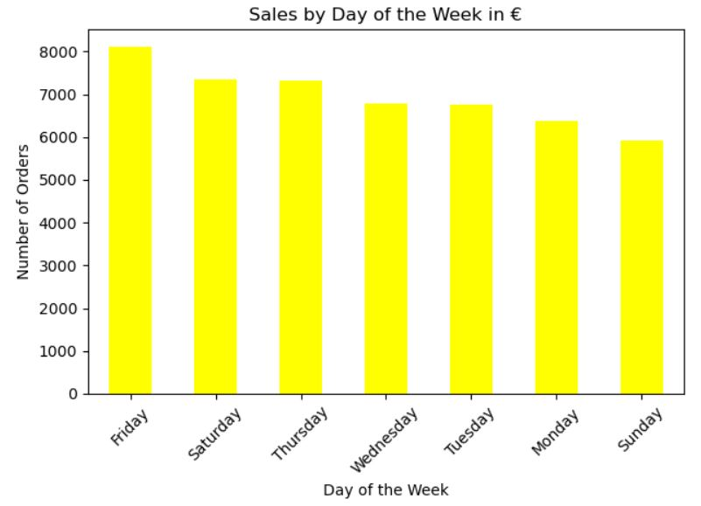

**Sales by Pizza Category:** A bar chart showing the total sales for each pizza category (Classic, Supreme, Vegetarian, Chicken). This will highlight the most popular categories, which is Classic Pizza and next one- Supreme.

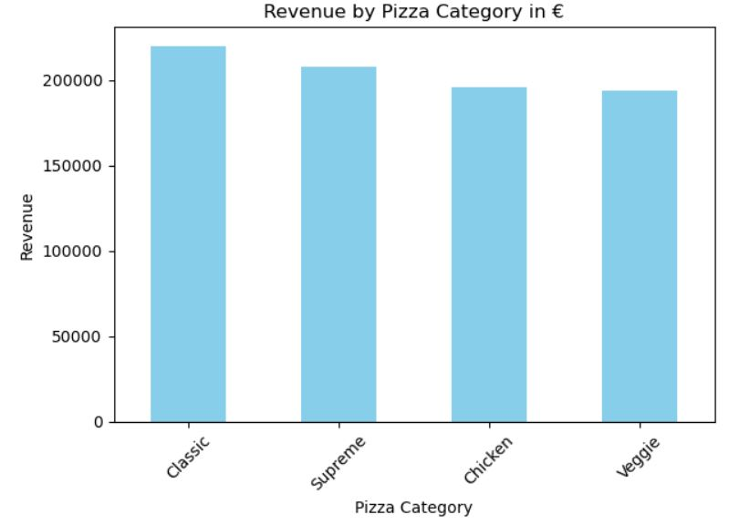

**Pizza Size Distribution:** A pie chart showing the percentage of orders for each pizza size (Small, Medium, Large, X-Large). This will illustrate the distribution of pizza sizes ordered. Again the Classic Pizza shows as most ordered.

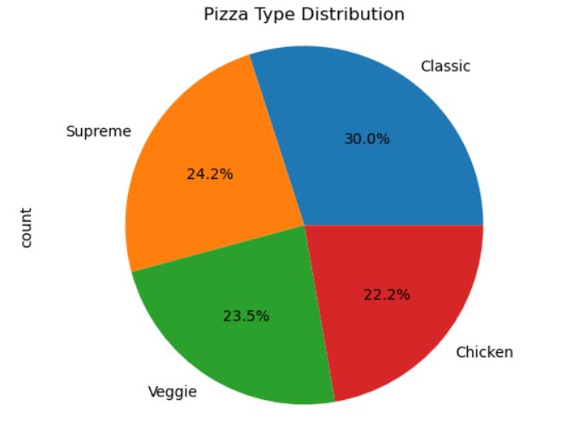

**Hourly Sales Trend:** A line chart showing total sales for each hour of the day. This will reveal peak ordering hours. We can observe that the peak hours are 12 to 13 and 17 to 18.

Outliers in the total_price column were identified using the interquartile range (IQR) method. Values outside the range of Q1 - 1.5*IQR and Q3 + 1.5*IQR were considered outliers. These outliers were not removed but were noted for further investigation as they could represent large orders.

**Data Type Conversions and Consistency Checks**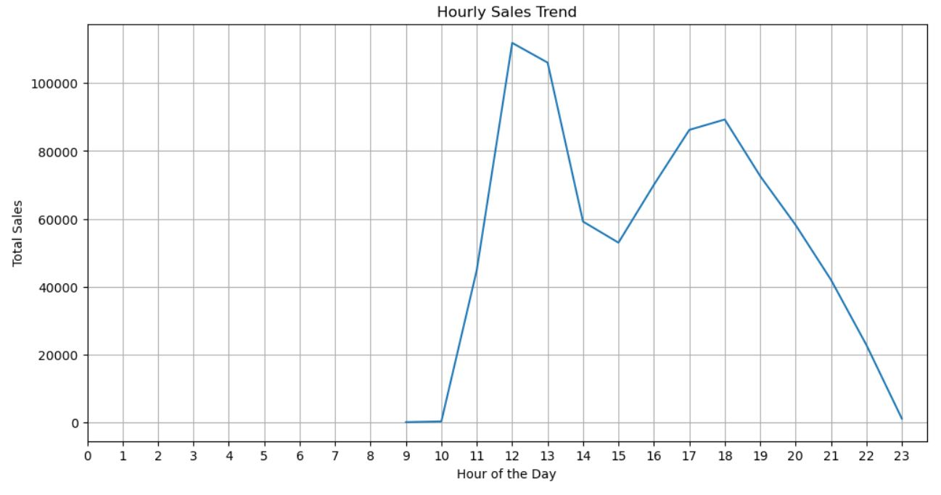

# References